# What is React Js?

React is a javascript library for building web interfaces.

More Better while Creating the UX/UL. The library makes your life easier due to code Reusalblity.

The link is been given <https://react.dev/learn> .

1. The current version is V18
2. Initial launch in 2013
3. Handle by Meta
4. 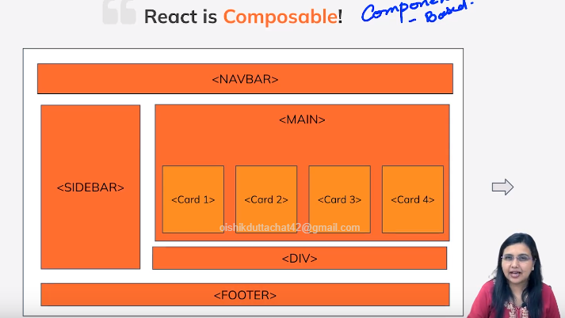
5. Helped us to Code Reusability.
6. Bullied the Single page Application which has the Single Html Document which makes this a very Dynamic and Components based wise Design.

# SPA AND MPA == Single Page Application and Multi-page Application overview.

***Multi-Page-application:***

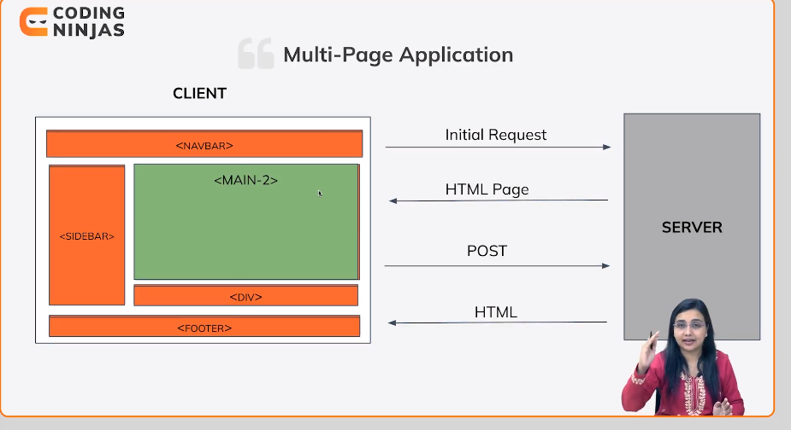

***Single Page Applications:***

Single page applications are used to load on a single Html Document Which is been Extracted by javaScript via AJEX Apis.

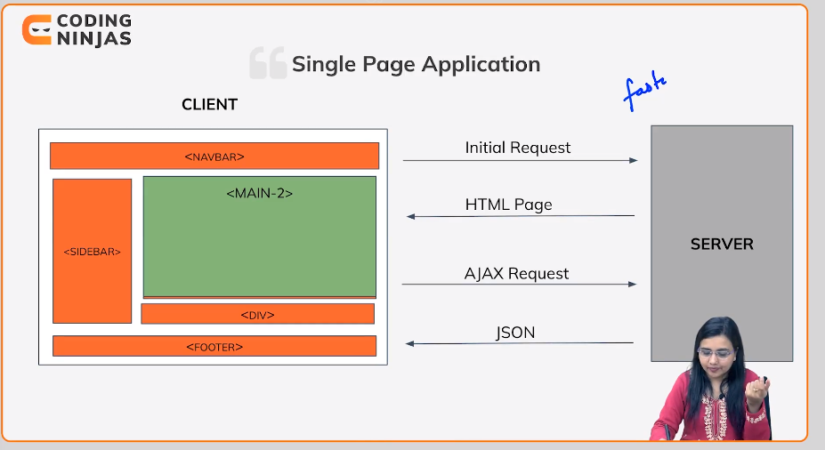

## React Is Declarative